**Documentation for codes for Learned Communication systems by Rishabh Pomaje**

# deepSISOnoCSI.ipynb

1. (7, 4) code system (in case of a coding enabled system)
2. Channel model
   1. AWGN :
   2. Rayleigh fading:
      1. Flat-fading model:
      2. Fast-fading model: Every BPSK symbol experiences a different fading tap sample.
3. **NO CSI** has been assumed either at the transmitter or the receiver.
4. BPSK modulation (only real axis used but channel is complex)

**Benchmarks:**

1. Uncoded (4, 4) BPSK – Orthogonal, *non-coherent* signalling
2. Hamming (7, 4) Hard – Orthogonal, *non-coherent* signalling

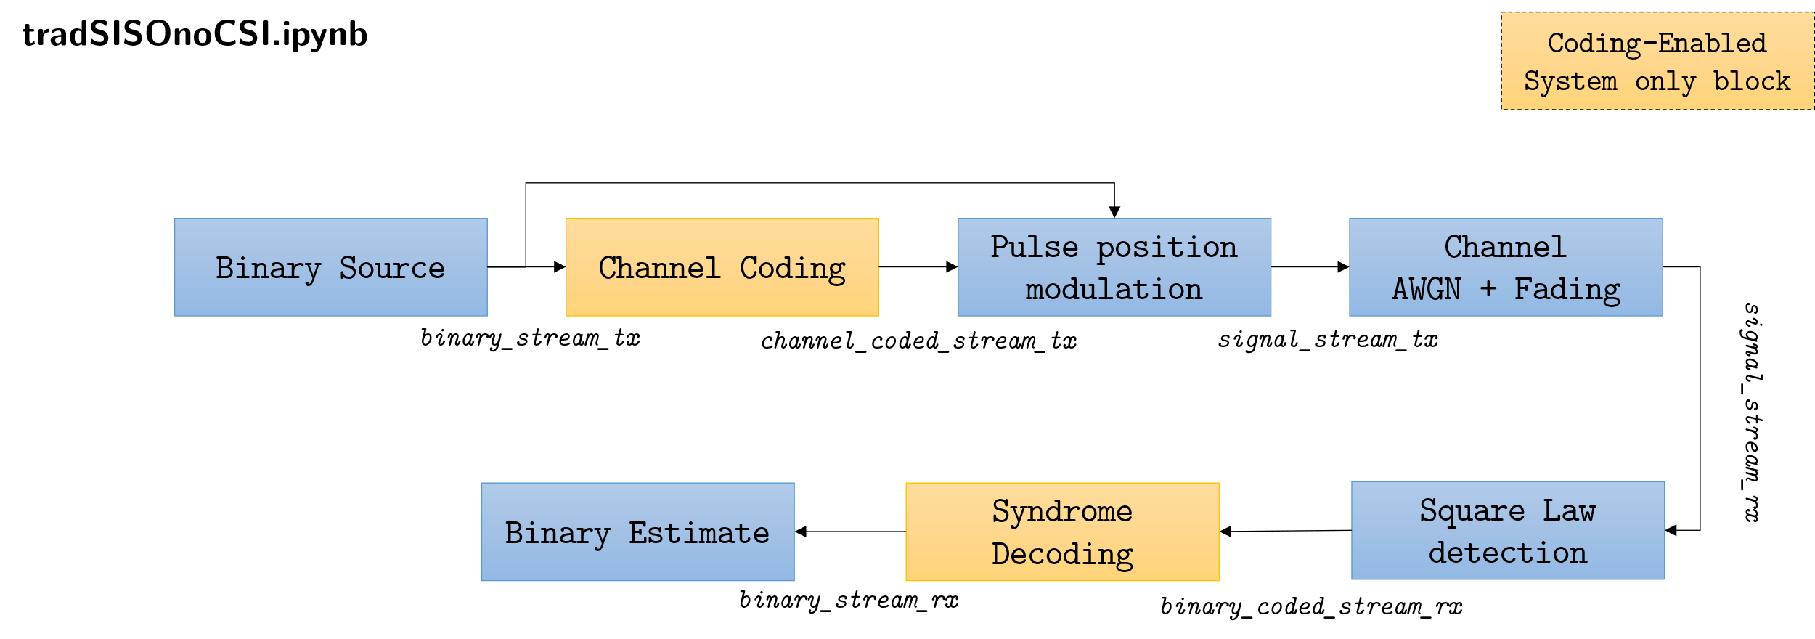

# deepSISOCSIR.ipynb

1. (7, 4) code system (in case of a coding enabled system)
2. Channel model
   1. AWGN :
   2. Rayleigh fading :
      1. Flat-fading model:
      2. Fast-fading model: Every BPSK symbol experiences a different fading tap sample.
3. **Perfect CSI** at receiver has been assumed either at the receiver exclusively.
4. BPSK modulation (only real axis used but channel is complex)

**Benchmarks:**

1. Uncoded (4, 4) BPSK; Coherent Detection
2. Hamming (7, 4) Hard; Coherent Detection
3. Hamming (7, 4) MLD; Coherent Detection

